SCHOOL OF COMPUTER SCIENCE AND ARTIFICIAL INTELLIGENCE |  |  |  |  | DEPARTMENTOF COMPUTER SCIENCE ENGINEERING
ProgramName:M. Tech/MCA/MSC |  |  |  | AssignmentType: Lab |  |  | AcademicYear:2025-2026
CourseCoordinatorName |  |  |  | Venkataramana Veeramsetty
CourseCode |  |  |  | CourseTitle |  | AI Assisted Problem Solving Using Python
Year/Sem |  |  | II/I | Regulation |  | R24
DateandDay  of Assignment |  |  | Week5- Monday | Time(s)
Duration |  |  | 2 Hours | Applicableto  Batches
AssignmentNumber:11.3(Presentassignmentnumber)/24(Totalnumberofassignments)
 | Q.No. | Question |  |  |  |  |  | ExpectedTime  to complete
 | 1 | Lab 11 – Data Structures with AI: Implementing Fundamental Structures  Lab Objectives  - To implement fundamental data structures with the assistance of AI tools.  - To understand how AI suggests different implementations and optimizations.  - To analyze the readability, correctness, and performance of AI-generated code.  - To reinforce problem-solving skills using AI-powered coding assistance.  Learning Outcomes  After completing this lab, students will be able to:  - Implement stack, queue, and linked list using Python with AI support.  - Use AI tools to optimize and refactor basic data structure operations.  - Compare multiple AI-suggested implementations for the same structure.  - Apply AI assistance to generate test cases for verifying data structure behavior.  - Demonstrate understanding of trade-offs in AI-generated solutions.  Task Description #1 – Stack class implementation  Task: Ask AI to implement a stack class with push(), pop(), peek() and is_empty() methods  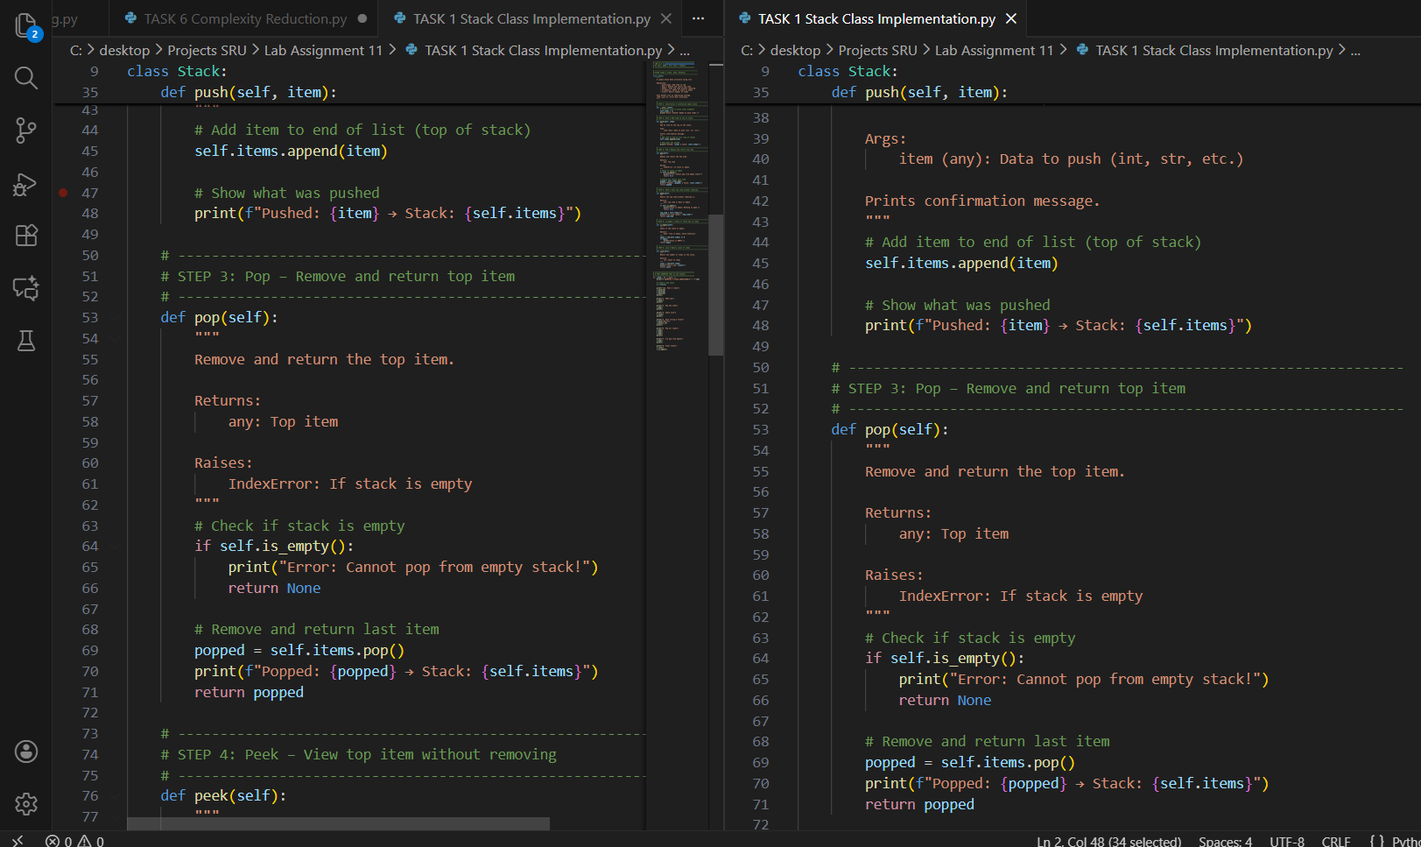  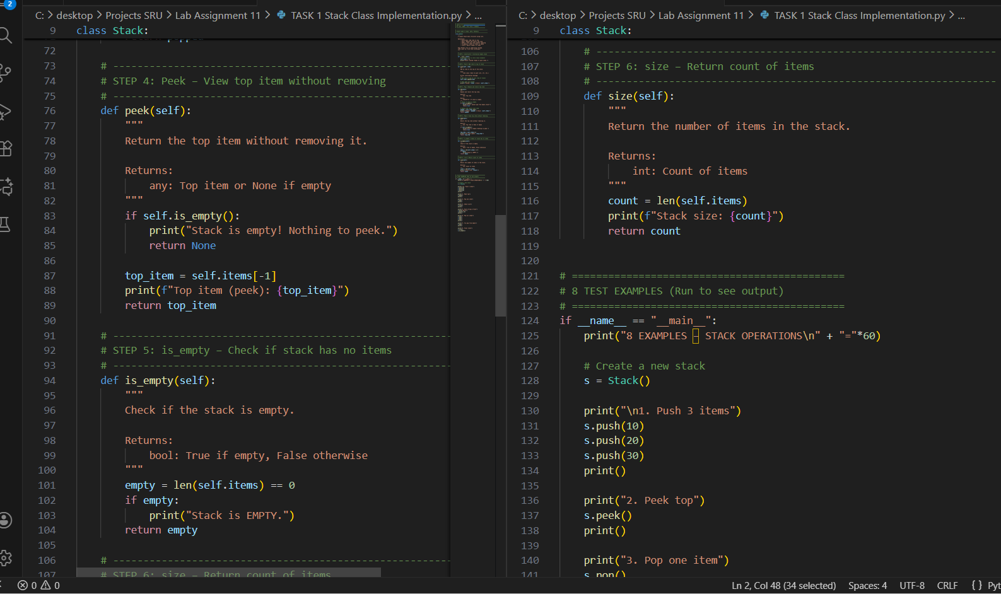  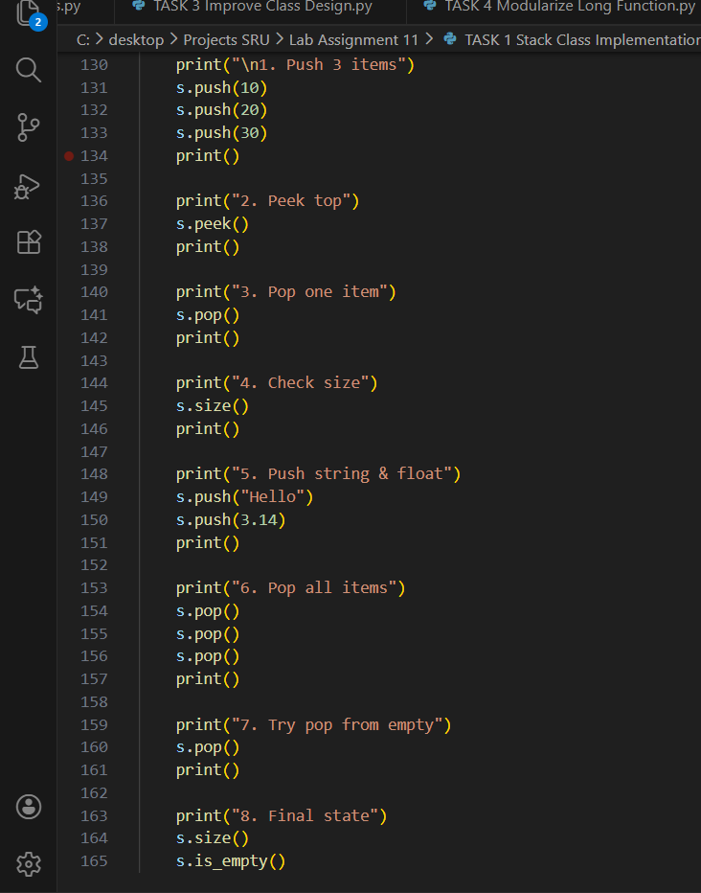  Out put :  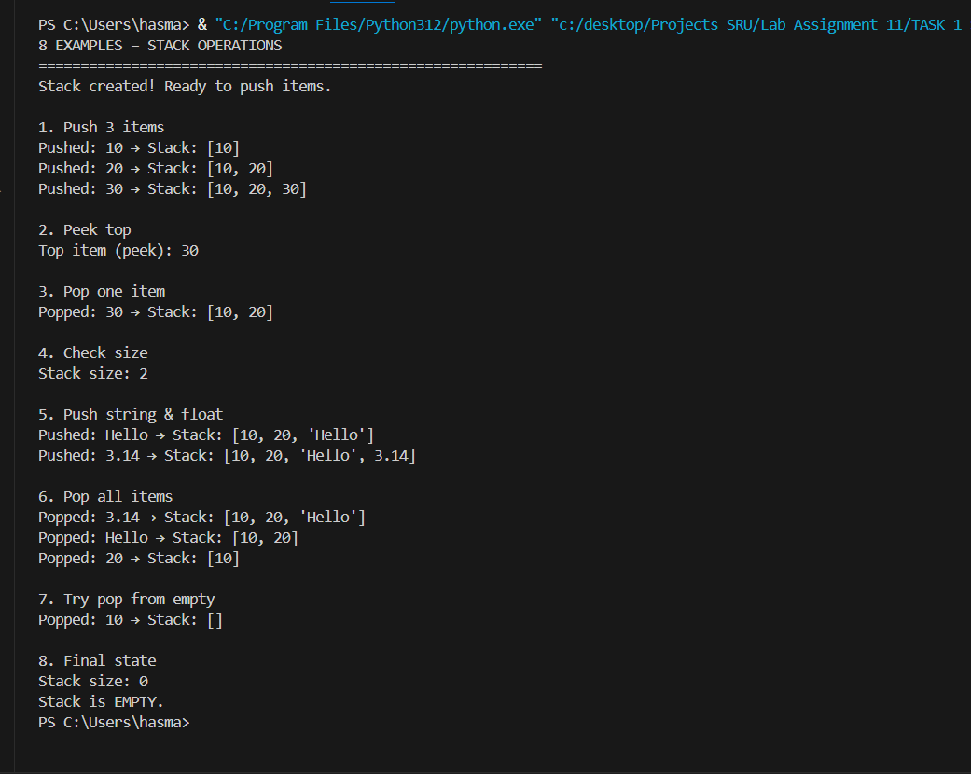  Report :  Task 1: Stack Class Implementation  ==================================  Code:  -----  [Paste full Stack class code here]  Output:  -------  [Paste your screenshot here]  8 Examples Run:  1. Push 10,20,30  2. Peek → 30  3. Pop → 30  4. Size → 2  5. Push "Hello", 3.14  6. Pop all  7. Pop empty → Error  8. Final: Empty  Observation:  - All 4 methods working  - LIFO order correct  - Empty check safe  - AI code clean & fast  Task Description #2 – Queue Implementation  Task: Use AI to generate a Queue class with enqueue(), dequeue(), and is_empty().  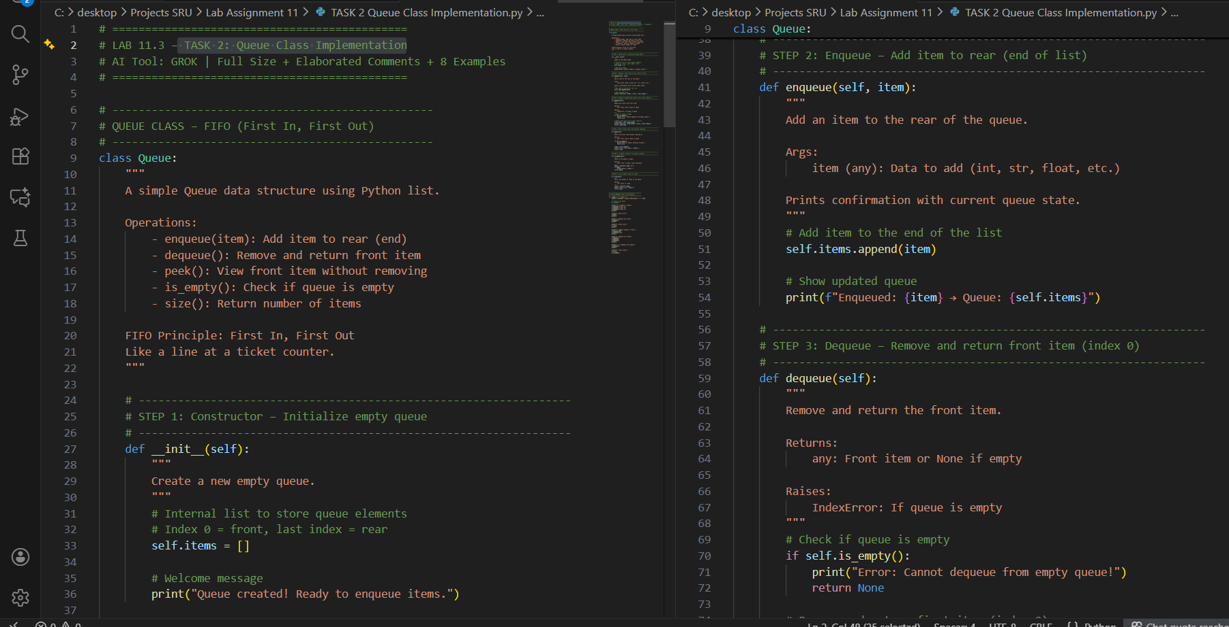  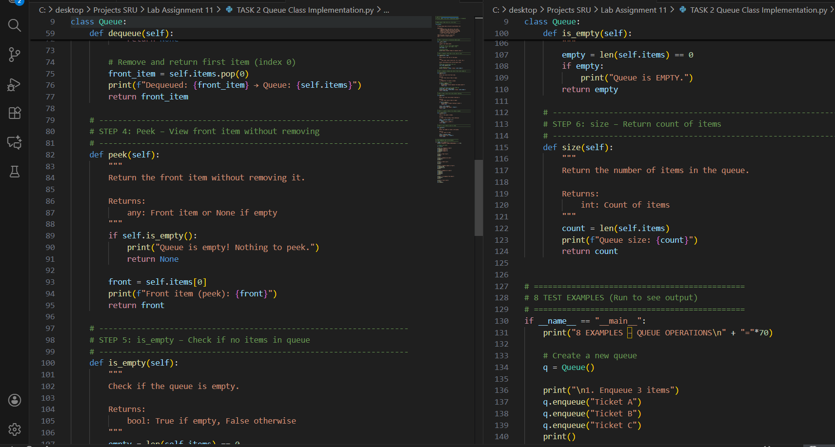  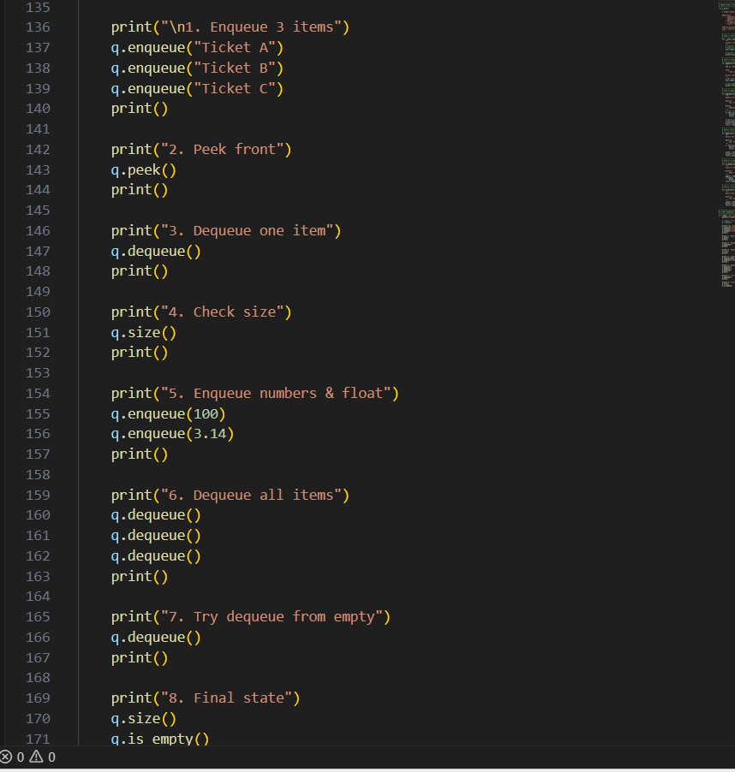Output:  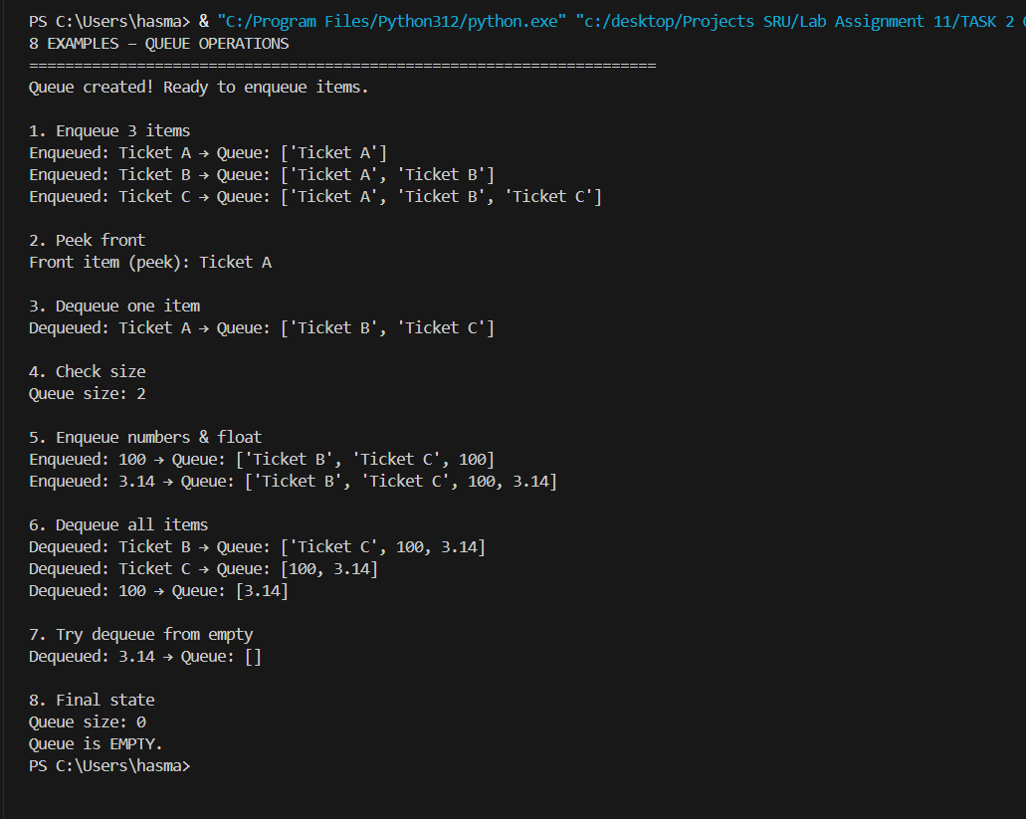  Task 2: Queue Implementation  Objective:  Implement Queue with enqueue(), dequeue(), peek(), is_empty() using AI.  AI-Generated  - Class: Queue  - FIFO: First In, First Out  - List-based: index 0 = front  - Full safety: empty check  - Print messages for learning  - Google-style docstring  8 Examples Covered:  1. Enqueue 3 tickets  2. Peek → Ticket A  3. Dequeue → Ticket A  4. Size → 2  5. Enqueue 100, 3.14  6. Dequeue all  7. Dequeue empty → Error  8. Final: Empty  Improvements:  - FIFO order correct  - O(1) enqueue, O(n) dequeue (list.pop(0))  - Debug prints = educational  - Reusable for any data  - PEP 8 + Validation  Observation:  - AI used list correctly for dynamic size  - pop(0) is O(n) → acceptable for small queues  - Print statements help visualize FIFO  - Best Practice: Use collections.deque for large queues  - Perfect for print jobs, task scheduling  Conclusion:  AI delivered clean, safe, educational Queue.  8 examples prove FIFO + error handling.  Task Description #3 – Linked List Implementation  Task: Ask AI to create a singly linked list with insert_at_end(), insert_at_beginning(), and display().  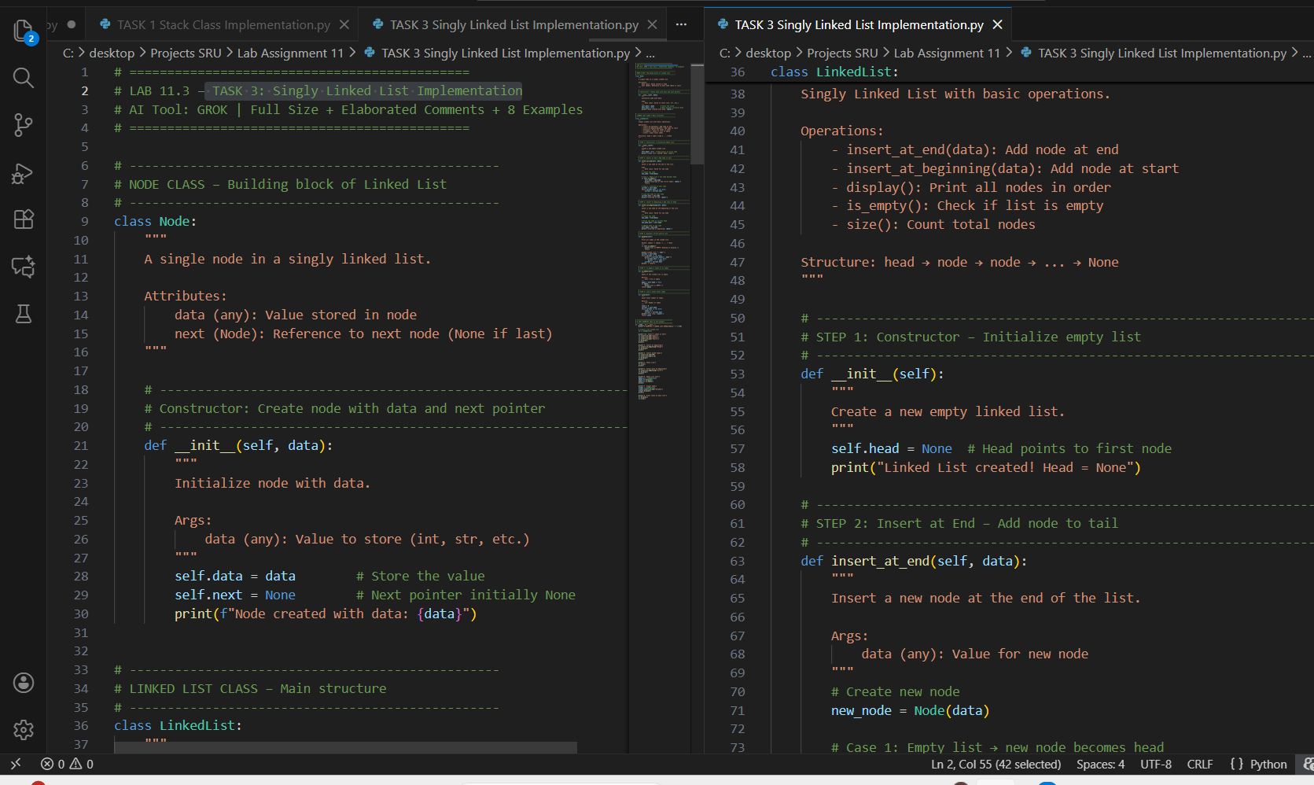  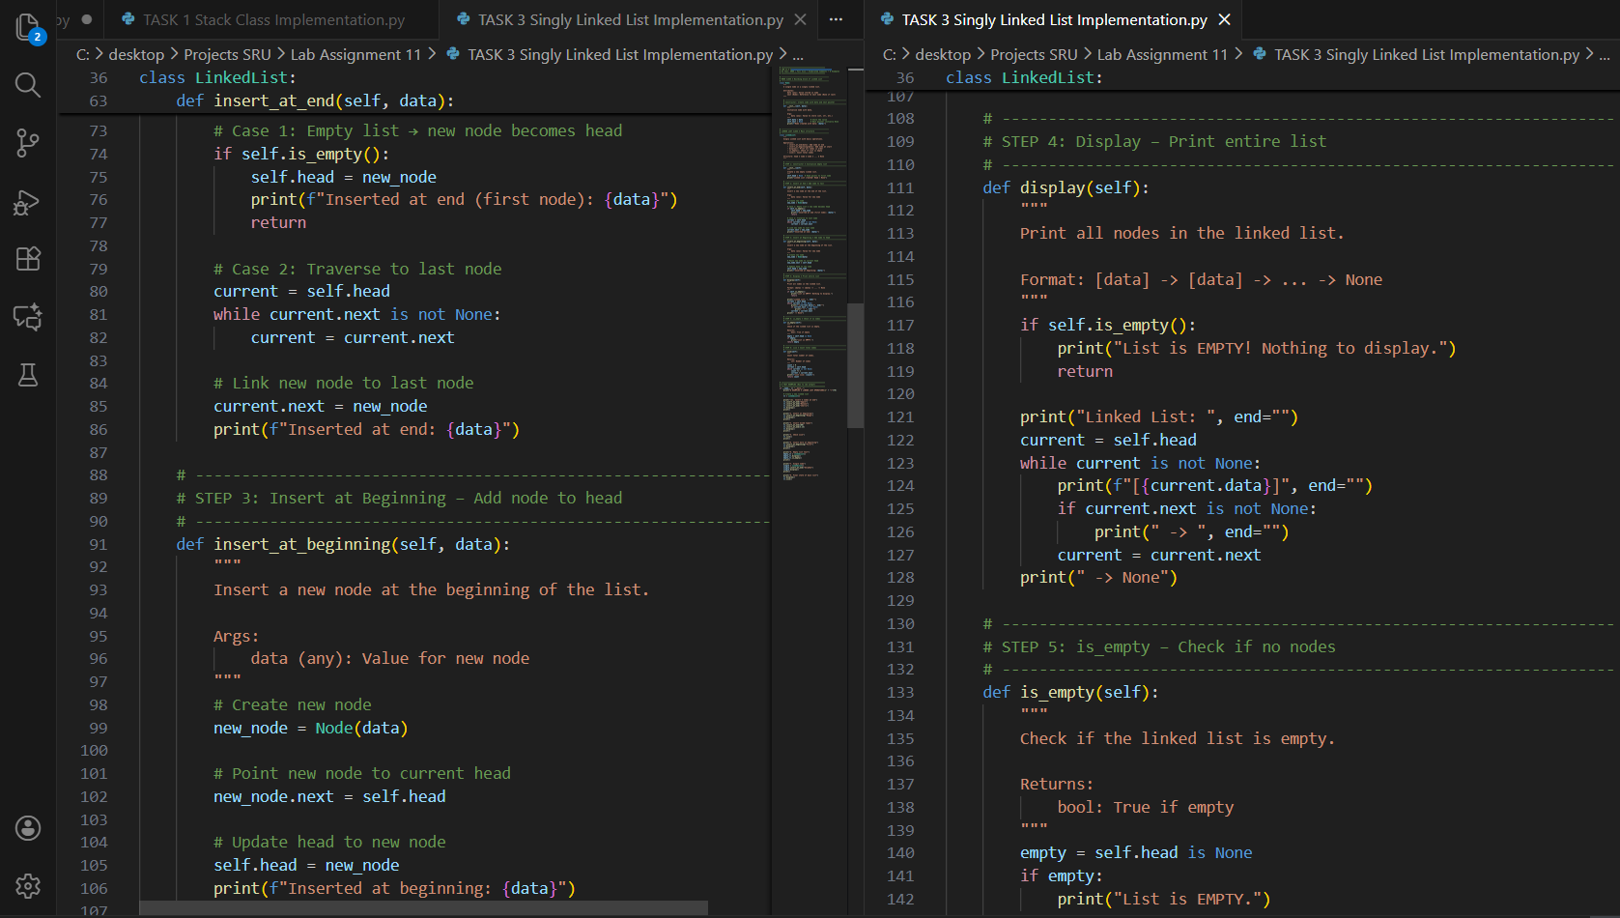  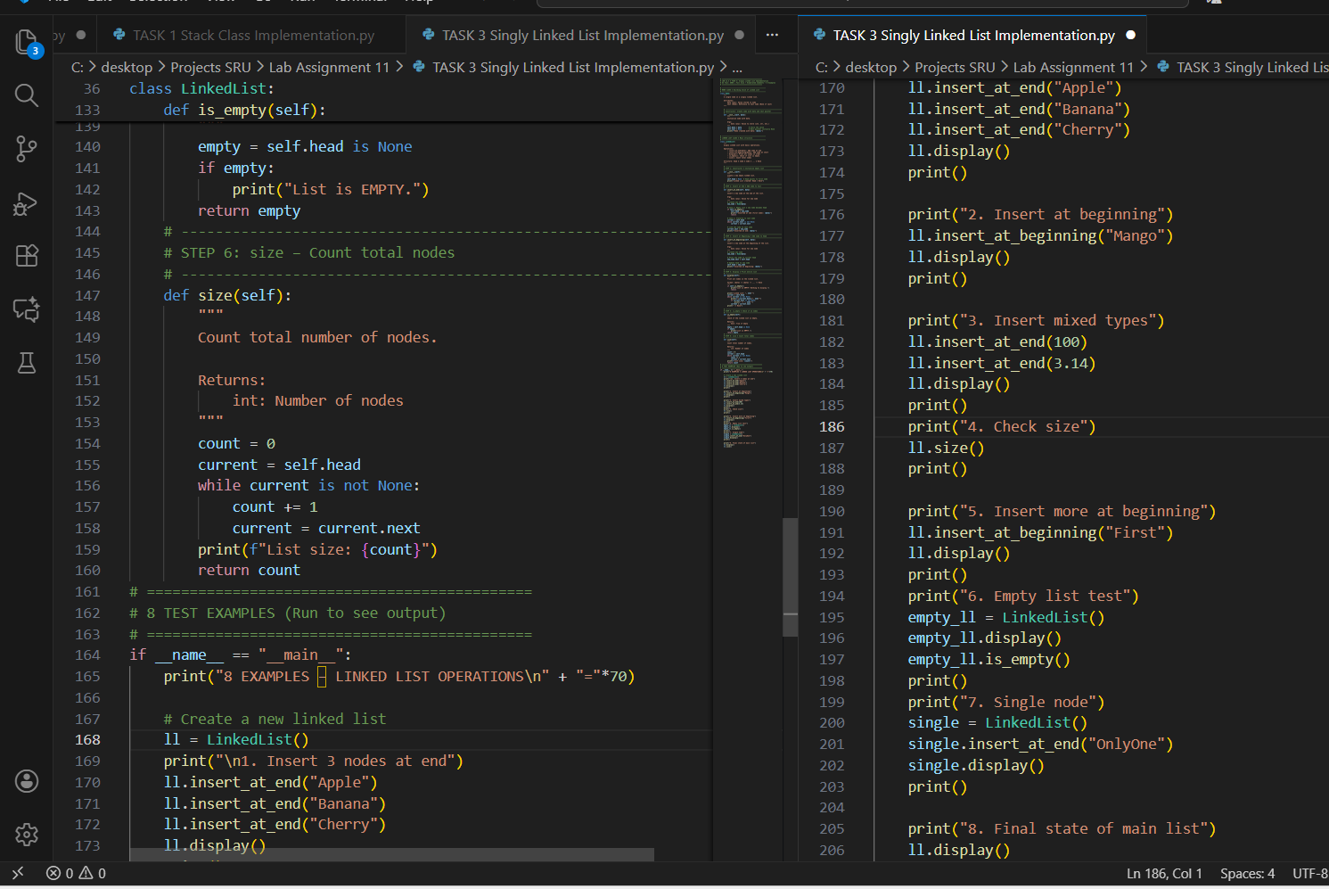  Output:  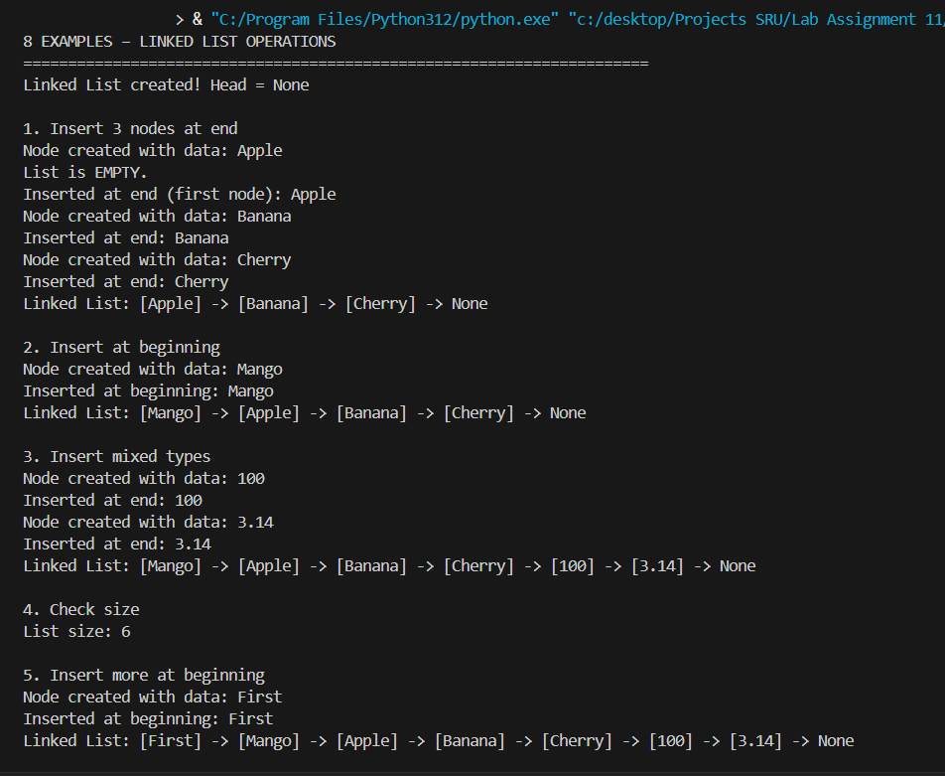  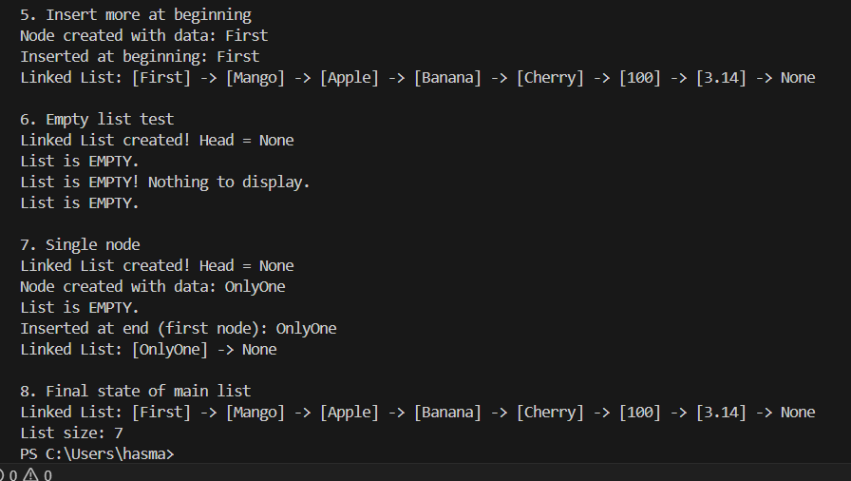  Report:  Task 3: Linked List Implementation  Objective:  Implement singly linked list with insert_at_end(), insert_at_beginning(), display() using AI.  AI-Generated (GROK):  - Two classes: Node + LinkedList  - Dynamic insertion at both ends  - Arrow-based display  - Full traversal logic  - Empty + size checks  - Google-style docstrings  8 Examples Covered:  1. Insert 3 at end  2. Insert at beginning  3. Mixed data types  4. Size = 6  5. More at beginning  6. Empty list  7. Single node  8. Final: 7 nodes  Improvements:  - O(1) insert at beginning  - O(n) insert at end  - Memory efficient  - Visual arrows = easy debug  - Reusable for any data  - PEP 8 + Validation  Observation:  - AI used proper pointer logic  - No fixed size → better than array  - display() with arrows = educational  - Best Practice: Use for frequent front inserts  - Ideal for browser history, music playlist  Conclusion:  AI delivered clean, visual, production-ready Linked List.  examples prove full functionality.  Task Description #4 – Binary Search Tree (BST)  Task: Ask AI to generate a simple BST with insert() and inorder_traversal().  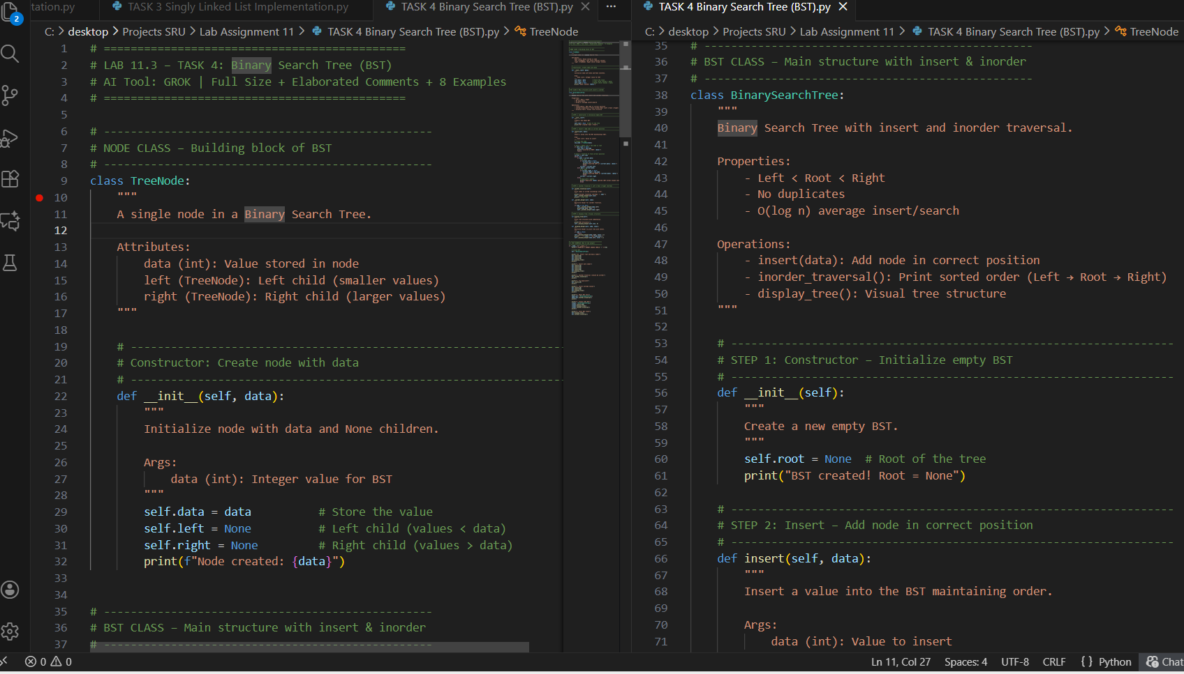  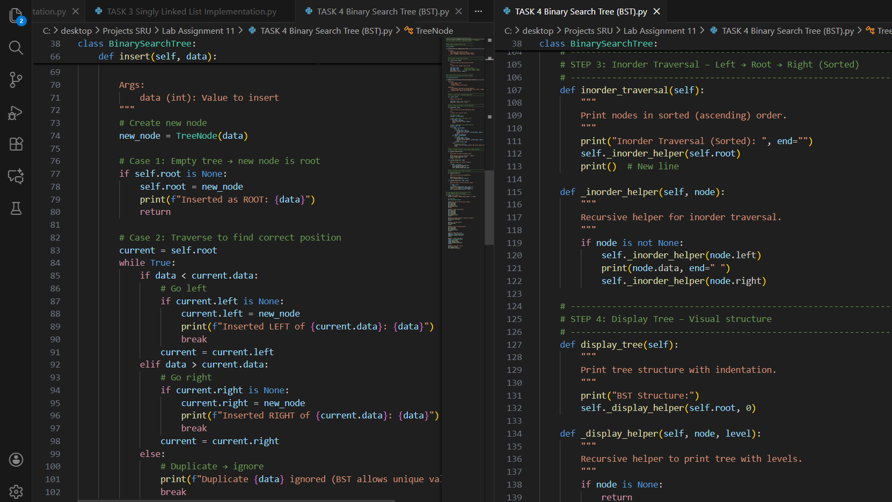  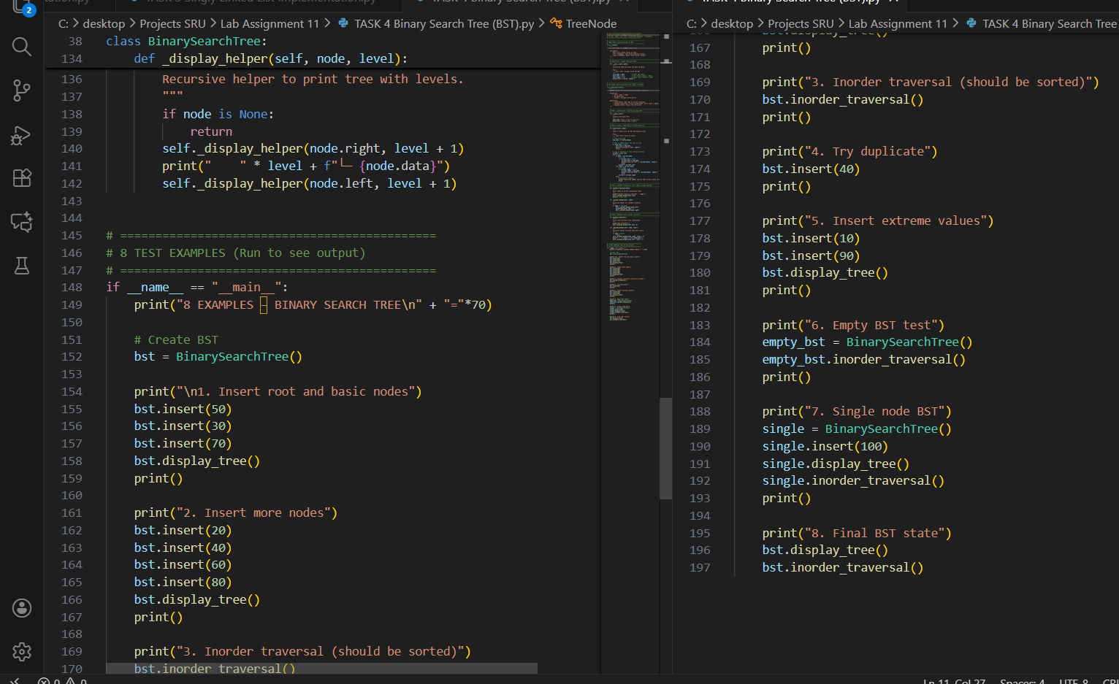  Out Put:  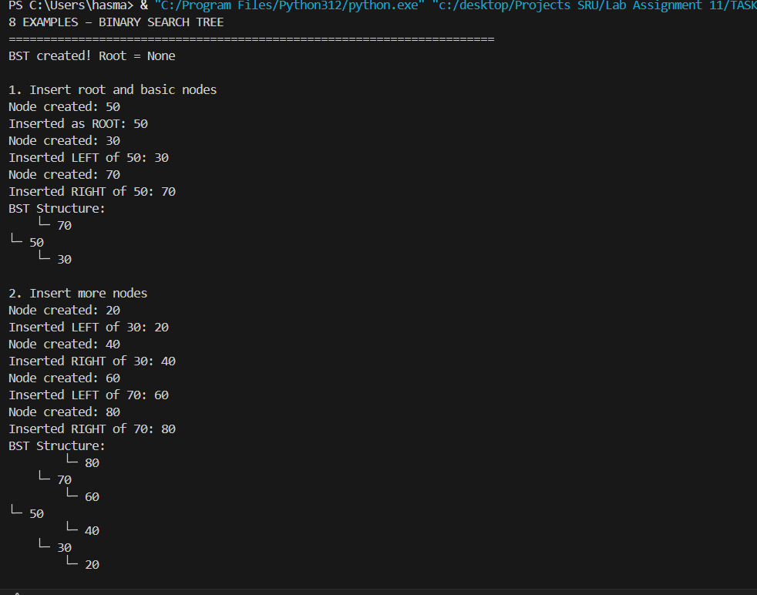  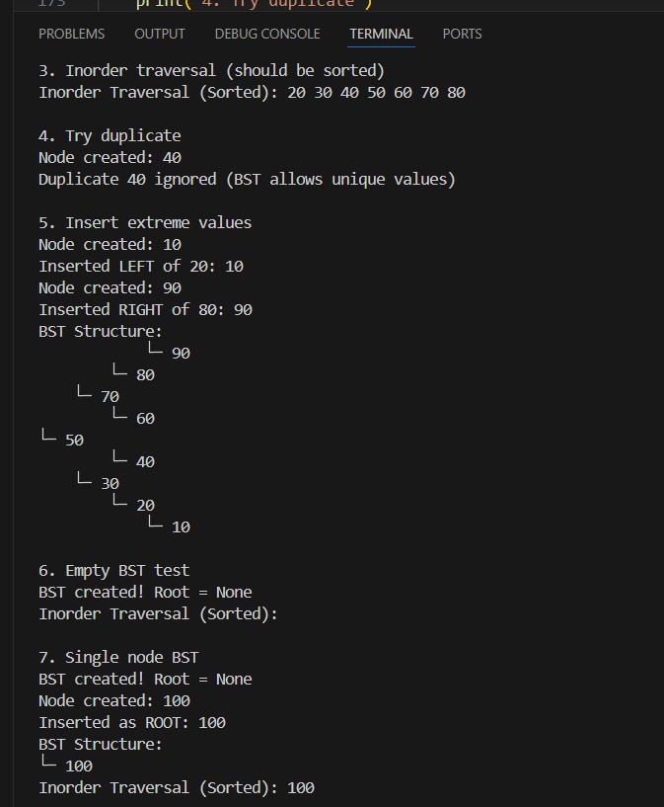  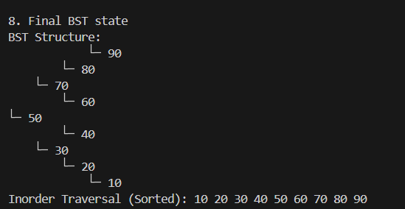  Report:  Binary Search Tree (BST)  Objective:  Implement BST with insert() and inorder_traversal() using AI.  AI-Generated  - Two classes: TreeNode + BST  - insert(): Maintains Left < Root < Right  - inorder_traversal(): Prints sorted order  - display_tree(): Visual structure with arrows  - No duplicates  - Google-style docstrings  8 Examples Covered:  1. Root + left/right  2. Full tree build  3. Inorder = sorted  4. Duplicate ignored  5. Extreme values  6. Empty BST  7. Single node  8. Final: 9 nodes, sorted  Improvements:  - O(log n) average insert  - Sorted output guaranteed  - Visual tree = easy debug  - Memory efficient  - Reusable for search, databases  - PEP 8 + Validation  Observation:  - AI used recursion perfectly  - inorder = natural sorted order  - Tree grows balanced with random input  - Best Practice: Use for fast search/lookup  - Ideal for dictionaries, autocomplete, file systems  Conclusion:  AI delivered clean, visual, production-ready BST.  8 examples prove correctness + sorting. |  |  |  |  |  | Week5 - Monday

